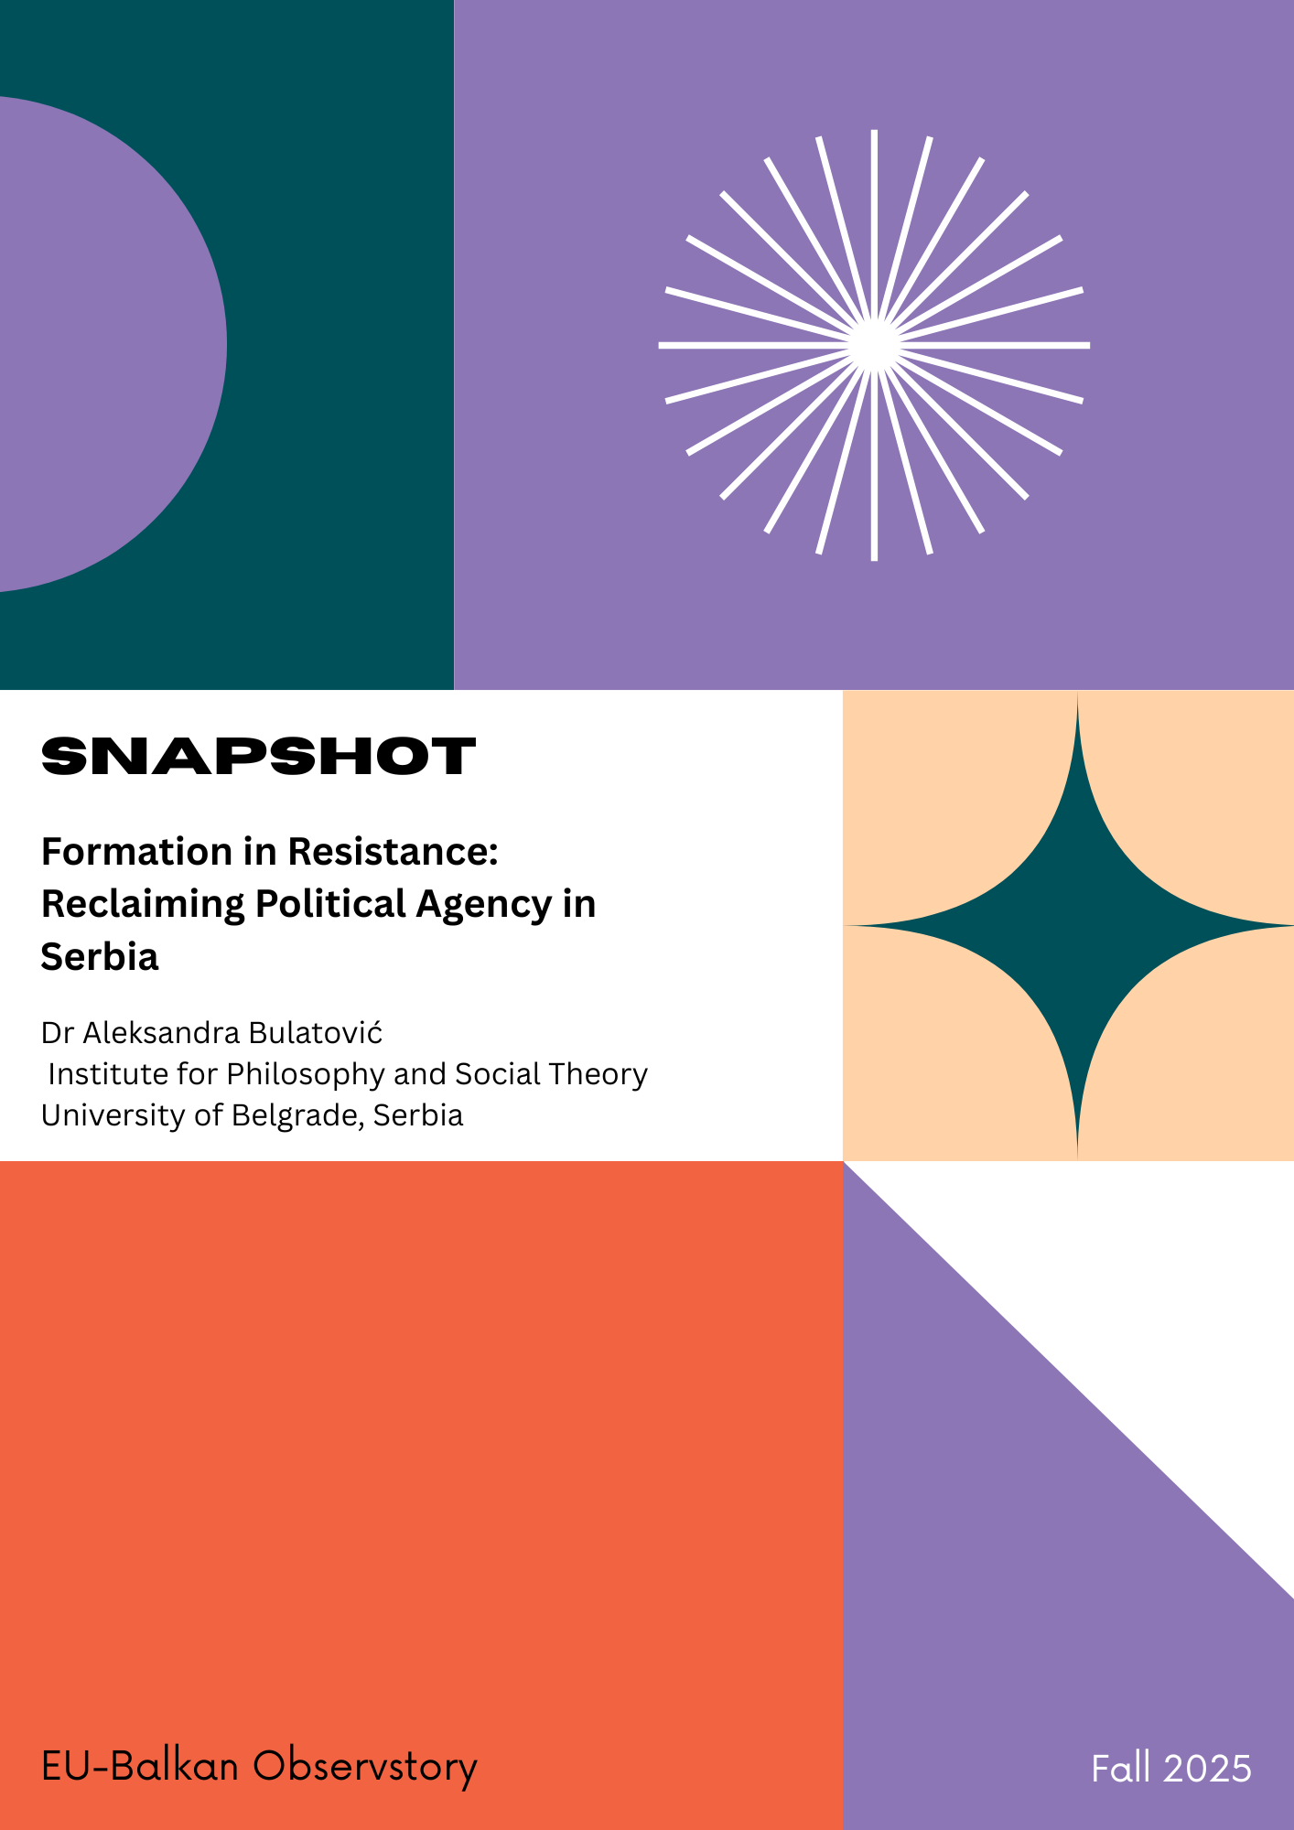

Dr Aleksandra Bulatović
Associate Research Professor
Institute for Philosophy and Social Theory
University of Belgrade, Serbia

Formation in Resistance: Reclaiming Political Agency in Serbia
The Serbian student uprising is more than a protest. It is a process of political reconfiguration in which citizens refuse to be represented and instead enact a politics of presence, horizontality, and solidarity. Their power lies not in submitting demands to the state but in forming a commons, a shared political horizon built through collective practices of care, resistance, and imagination. By occupying universities, participants turned spaces of bureaucratic inertia into spaces of invention. What emerged was not simply opposition to authoritarianism but the formation of new political subjects and new ways of living democracy.
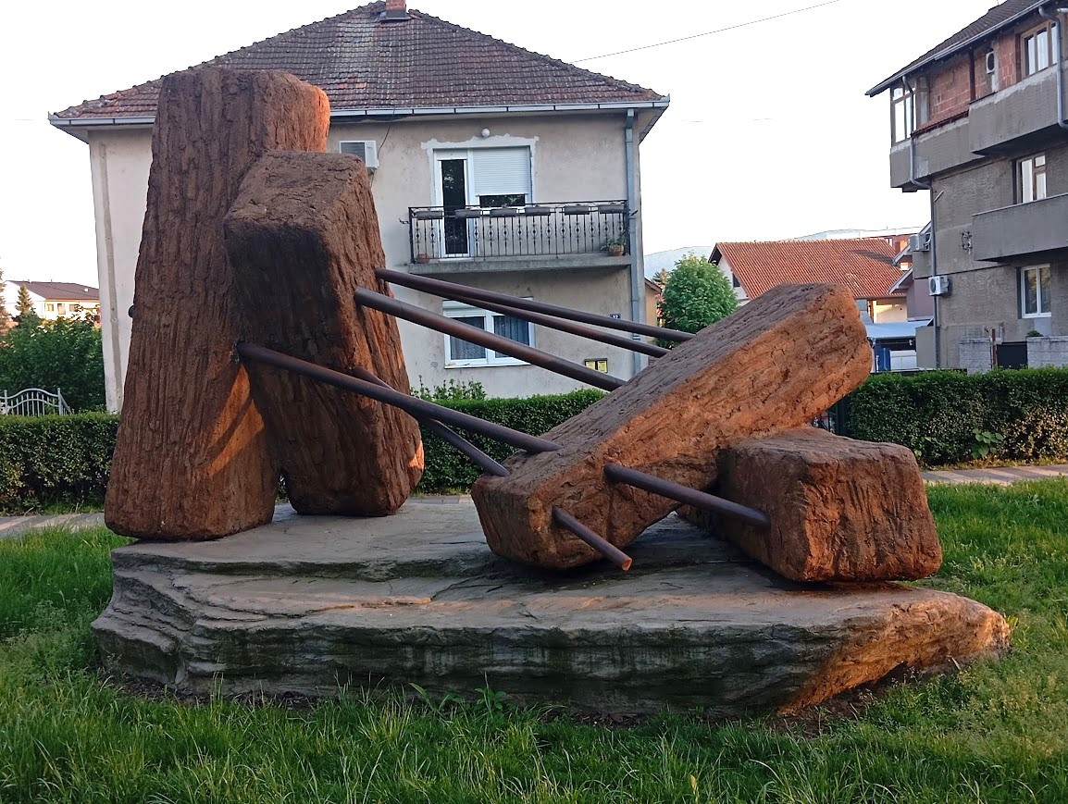
The uprising emerged in a country where institutions were eroding, state violence had become normalized, and authoritarian rule was presented as stability. Serbia’s regime controlled the media, manipulated elections, repressed protests, and devalued education and critical thought. Universities, once somewhat independent, were subordinated to political loyalty. Faculty were appointed on partisan grounds, student bodies were depoliticized, and knowledge was reduced to a commodity. After years of scandals, violent police crackdowns, and cynical exploitation of tragedies, students and other civic actors who had long been dismissed as irrelevant suddenly took to the streets and occupied university buildings. What began as a reaction to specific issues quickly turned into a refusal of politics as usual.
The regime tried to impose its narrative. State media labeled participants as troublemakers, critical voices were silenced, and nationalism was mobilized to portray the protests as foreign-driven. During the summer months that followed, state authorities escalated repression. Peaceful protesters were beaten by police, disciplinary and criminal proceedings were initiated against participants, and public sector employees faced dismissals for their involvement. Despite these pressures, citizens persisted, demonstrating resilience and the capacity to maintain collective action under constant threat.
Through collective practices, participants constituted themselves as political subjects. They were not passive recipients of repression but agents of new forms of politics. In occupied halls and improvised assemblies, decisions were made by consensus, tasks were distributed, and care became a political principle. Meals were shared, legal aid was provided, mental health was addressed, and cultural events were organized. The university became a commons, a living political laboratory where citizenship and cooperation were tested in real time.
This horizontality was a source of strength. By refusing leaders and fixed demands, participants resisted cooptation and created a different democratic grammar rooted in dialogue, mutual recognition, and inclusivity. New solidarities emerged, most notably the Solidarity Network of IT Serbia, created to ensure that educators who resisted state pressure could continue to receive support. This unprecedented initiative allowed others in society, who otherwise could not participate in such direct action, to engage in the resistance, establishing an alternative model of civic action. The large response of donors confirmed that solidarity was understood as a political act, in which responsibility for achieving a shared political goal is collectively assumed. In a context where years of anomie had deeply shaped civic life, this initiative restored agency to participants, demonstrating that neither poverty nor deprivation could prevent them from acting as active members of the political community. In this sense, resistance was not only opposition to power but also creation of alternatives.
At the core of the uprising was a dense emotional economy. The protests grew out of anger, exhaustion, fear, and humiliation, but these emotions were transformed into solidarity and care. Occupied spaces became places of healing as much as resistance. Participants recognized emotional labor, spread tasks to prevent burnout, and created rituals of togetherness such as singing, sharing meals, or moments of silence. These practices turned vulnerability into resilience.
The uprising unfolded simultaneously in physical and digital spaces. University occupations were places of assembly and identity formation, while social media, messaging apps, livestreams, and memes enabled organization, communication, and expression. Digital tools allowed for rapid coordination, but also for irony, humor, and art that undermined authoritarian narratives while building community. Online debates informed offline strategies, and viral posts became calls to action. This interplay of digital and physical spaces gave the movement flexibility, allowing it to adapt under repression. What emerged was a new civic imagination that combined local practices with global networks.
The Serbian uprising demonstrates that political change is not only about resisting power but about imagining and building new ways of living together. Transformation begins with formation: the creation of new subjects, spaces, and practices. Young people and other engaged citizens were central to this process because they retained the imagination to envision different futures and the courage to commit to them. Their capacity to learn through struggle and their dedication to solidarity show that imagination is not utopian detachment but a practical force of resistance.
As civic actors across Southeast Europe confront hostile conditions, the Serbian experience offers a lesson that resonates more widely. Democracy cannot survive without imagination, solidarity, and the commons. These participants remind us that frustration can give way to formation, and formation can create the shared horizons on which political futures depend. A striking symbol of this tension is the sculpture “Span in Tension,” which embodies the precarious balance between pressure and resistance. Serbian society lives in a similar balance, stretched thin but still enduring. The student uprising demonstrates how pressure can transform into creative resilience, where emotional investments become active forces that sustain political life.

